Blooming Acres Sewing and Crafting Studio
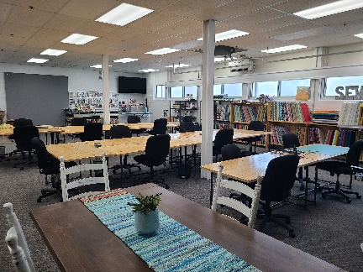
Becka Owen, owner of Blooming Acres in Mt. Vernon
221 1st Street NE, Mt. Vernon, IA 52314
319-560-6124

The studio is a newly renovated area with an open floor design. It includes 15 work tables and office chairs, 2 ironing stations, 2 quilt design walls, a kitchenette with a fridge, stove, sink, microwave, dining table, free WI-FI, a 55-inch Smart TV, and lots of natural light.

The studio is located in the lower level of the historic First Street Building in Mount Vernon. Overnight accommodations are available at Sleep Inn & Suites Mount Vernon, or Brackett House Bed and Breakfast on the Cornell College Campus.

You can access the studio by parking on the side of the building and taking the sidewalk down around the building (no steps). There are 2 parking spots by the back door for unloading. These spots can also be used for handicap parking. There are 2 restrooms off the studio. One has no steps, the other has 2 steps.

Becka would be happy to let OCQG guild members use her space to sew and to shop. If it is a one-time event, there is no charge. The best available times are when her shop is open Tuesdays and Thursdays 10-4, and Wednesdays 10-4 when there is not an early dismissal. Becka recommends calling her shop at 319-560-6124 to verify the studio is not reserved if you are going to drop in and sew.

If a reservation is needed, the rate is currently a discounted price of $10 per person/per day (normally $15), so quilters can come and try it out. If you want to make a reservation for yourself or your group, call to reserve your date(s) and the time you will arrive and leave each day. People can leave their sewing machines, supplies and projects there overnight since the doors are locked after hours.

Becka has 6 new Janome home sewing machines that can be rented for $10/day. She also has a longarm business and can help you finish your beautiful quilt tops.

Becka is a wonderful advertiser and supporter of OCQG. She welcomes everyone to come and see her studio and spend the day sewing and checking out fabrics, patterns and kits in her store: https://bloomingacresmv.com/. She also sells on Etsy: https://www.etsy.com/shop/BloomingAcresDesigns

